**Geometriska former**

**Arean = basen . höjden**

**2**

**tetraeder**

**= höjden**

**=basen**

**parallellogram** [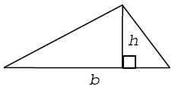](http://www.google.se/url?sa=i&rct=j&q=&esrc=s&frm=1&source=images&cd=&cad=rja&docid=yp1TV5Hv-TnwHM&tbnid=B1RGzWpq2ebzFM:&ved=0CAUQjRw&url=http%3A%2F%2Fwww.pluggakuten.se%2Fformelsamling%2Fmatematik%2Fgeometri&ei=YT91UsaKJ6SK4wSprYGIAw&bvm=bv.55819444,d.bGE&psig=AFQjCNE85Yb49bx50MPVfhrcd32IGG7HkQ&ust=1383502004121986)

**kon**

**rektangel** [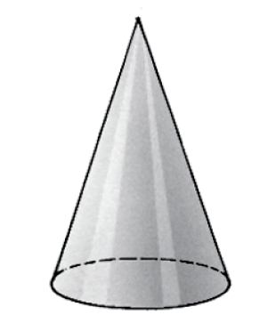](http://www.google.se/url?sa=i&rct=j&q=&esrc=s&frm=1&source=images&cd=&cad=rja&docid=whj0I_r2J6LqbM&tbnid=aSv87Dz65kBOfM:&ved=0CAUQjRw&url=http%3A%2F%2Fwww.ljungvallametall.se%2Fpage%2Fview%2Fprodukter%2F&ei=9jx1UpL7C6Oq4ASmkIGoDA&bvm=bv.55819444,d.bGE&psig=AFQjCNGd-wpd6KUnnn4PQba8L7doIwcJ7g&ust=1383501421925461)

**kvadrat**

**femhörning**

**parallelltrapets**

**cylinder**

**kub**

**klot**

**rätblock**

**cirkel**

**ellips**

**liksidig triangel**

**rätvinklig triangel**

**likbent triangel**

**romb**